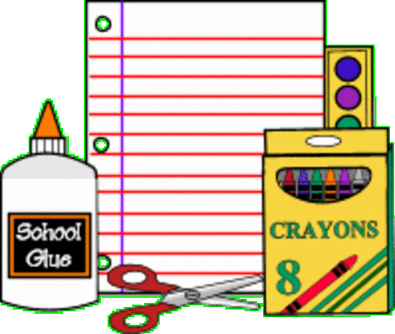
Kindergarten Supplies
- An extra pair of clothing in case of an accident. These clothes do not have to be purchased from Lands End but must be the same colors as our school uniform and in a Ziploc bag. Please include extra underwear and socks.
- A backpack, water bottle, and lunch bag (labeled with their name)
- Rain coat and rain boots to be left at school (send by October)
- 1 - two pocket vinyl (plastic) folder
Community Supplies
- 1 box Crayola colored pencils (10-12 colors – sharpened)
- 4-6 glue sticks (white - not purple)
- 2 small boxes of Crayola crayons (24 colors)
- 2 boxes of broad line Crayola markers (12 Classic Colors)
- 1 box of beginner jumbo pencils (sharpened)
- 1 box of #2 pencils (no designs – sharpened)
- 4 thick dry erase markers (low odor- color black)
- 4 thin dry erase markers (low odor – color black)
- 1 white board eraser
- Lakeshore Draw and Write Journal (available through Amazon)
https://www.amazon.com/Lakeshore-Learning-Draw-Write-Journal/dp/B004ZAKSPS/ref=sr_1_2?ie=UTF8&qid=1528827707&sr=8-2&keywords=writing+journal+kids
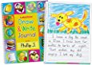
Mandarin Supplies
Please place the following supplies in a 1 gallon re-sealable storage bag labeled with your child’s name. These supplies will be for your child’s use while in Mandarin class.

- 2 ELMER’S washable School Glue Sticks
- Paper Mate® Pink Pearl® Eraser
- Crayola® Large Washable Crayons, Assorted Colors, Box Of 8
- 1 Crayola® Ultra-Clean Washable Markers, Broad Tip, Assorted Classic Colors, Box Of 10

